**GAME DESIGN DOCUMENT**

Snark Tank

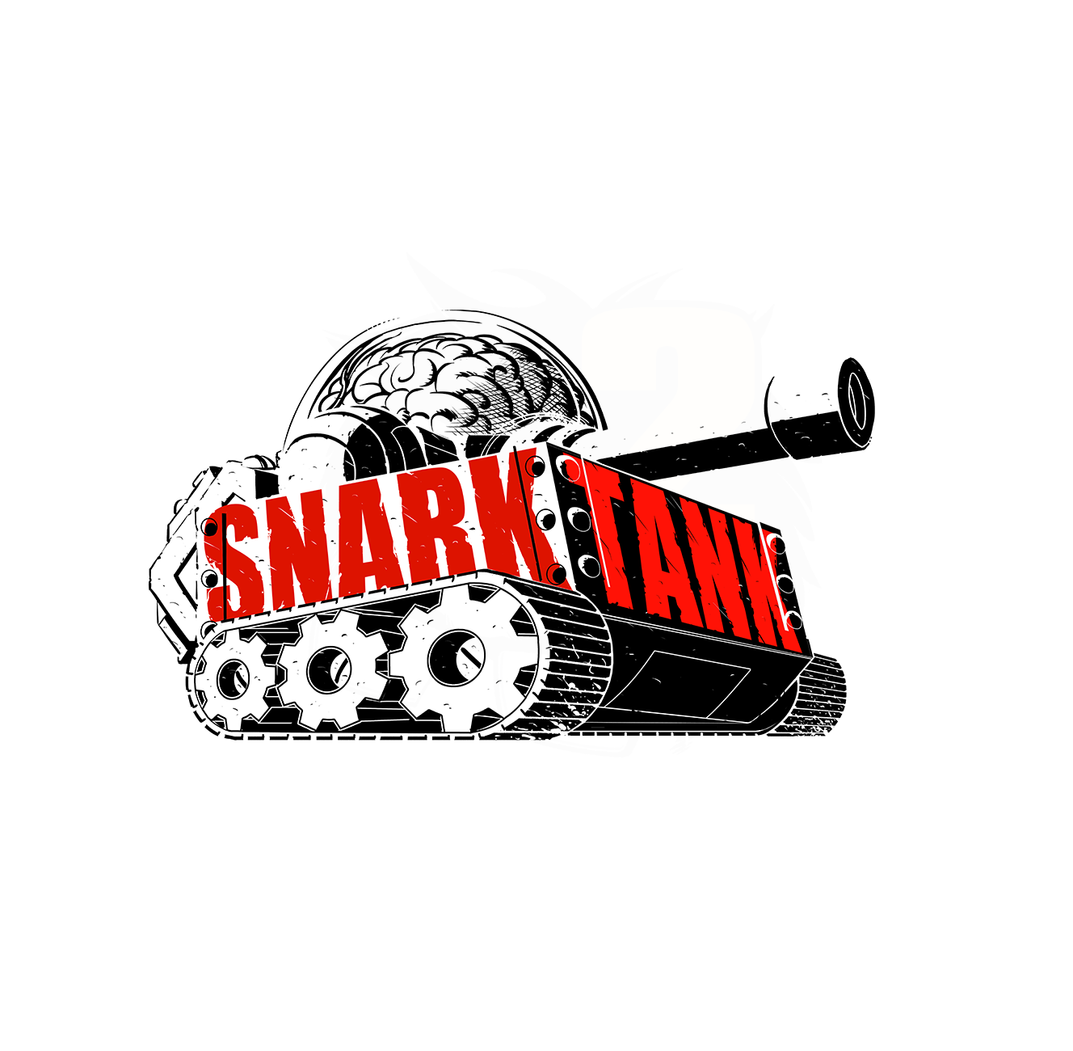

The Quest to Down the 3rd Twin Tower

**Last Updated:**

6/22/20

**Prepared By:**

Maximo [REDACTED]

**TABLE OF CONTENTS**

Game Analysis 3

Mission Statement 3

Genre 3

Platforms 3

Target Audience 3

Storyline & Characters 4

Gameplay 5

Overview of Gameplay 5

Player Experience 5

Gameplay Guidelines 5

Game Objectives & Rewards 5

Gameplay Mechanics 5

Level Design 6

Control Scheme 7

Game Aesthetics & User Interface 7

Schedule & Tasks 8

# Game Analysis

The basic underlying plot is that Paul has stolen the Snark tank and placed it upon the papa John’s 4 story fortress. The gang must enter from the ground floor and work their way through every floor until they reach the roof, where they then defeat Paul in the Snark tank.

# Mission Statement

This game is an homage to the work done by Chris Maldonado, Derrick SBG, and Tom Sweeny. The game is essentially an attempt to make a multi genre adventure, with the game mechanics themselves changing based on who you choose for that level. Specifically, selecting Chris gives the game a dungeon crawler + shooter basic system, with sweeny the game changes to an RPG, and with Derrick the game becomes a turn-based strategy game (thankfully the GameMaker engine, while outdated by several years, is perfect for this implementation)

# Genre

“selecting Chris gives the game a dungeon crawler + shooter basic system, with sweeny the game changes to an RPG, and with Derrick the game becomes a turn-based strategy game”

# Platforms

The target platform is PC (the best platform obviously), potentially have controller support.

# Target Audience

The audience is ideally the snark tank fans, they are plentiful and desire a large variety of human atrocities. Therefore, the multi gameplay style concept should help people choose whichever gameplay style they like best.

# Storyline & Characters

Due to my lack of understanding of Derricks content, the game will mostly revolve around ChrisRayGun & the limited Sweeny content available.

------------- REFRENCES LIST -------------

**The Snark Tank Podcast: #00 – Psychicpebbles**

Progerians

The Negro Beater (10:15)

Stolen PSP

**The Snark Tank Podcast: #01 – SomeBlackGuy**

Yellow shirt girl freaking Derrick out

Stinkbugs

**The Snark Tank Podcast: #02 - Tom Sweeny**

Robot Hands

Bionic knees

**The Snark Tank Podcast: #03 - Nakey Jakey**

Toaster Bathtubs

Leaper Leapord

Sweeny hates the kardashians

Yoshi Boots

**The Snark Tank Podcast: #04 - imAllexx**

Sweenies boulder slam

Sweeny Hates aliens

**The Snark Tank Podcast: #05 - Game of the Decade**

?

**The Snark Tank Podcast: #06 - Onision Bad**

Chris Hansen showing up unexpectedly

**The Snark Tank Podcast: #07 – Coronavirus**

Papa John

Kobe exploded

Crippled achillies heel

VATS system

**The Snark Tank Podcast: #08 - The Dating Game**

**The Snark Tank Podcast: #09 - Video Game Movies**

**The Snark Tank Podcast: #10 - Are We Weebs**

**The Snark Tank Podcast: #11 - Top Tier Television**

**The Snark Tank Podcast: #12 - Surviving Aliens**

**The Snark Tank Podcast: #13 - Evil Robits**

**The Snark Tank Podcast: #14 - Scary Stories**

**The Snark Tank Podcast: #15 - Snowflake and Safespace**

**The Snark Tank Podcast: #16 - Childhood Fictional Crushes**

**The Snark Tank Podcast: #17 - Film Failures**

**The Snark Tank Podcast: #18 - Katerino Drama**

**The Snark Tank Podcast: #19 - Weekend at Kim Jong's**

**The Snark Tank Podcast: #20 - The Last of Us Leaks**

**The Snark Tank Podcast: #21 - The Last Great Spoof Movie**

**The Snark Tank Podcast: #22 - The Twitch Deer Girl**

**The Snark Tank Podcast: #23 - Keemstar Wars**

**The Snark Tank Podcast: #24 - Sweeny Hates Aliens**

Aliens

**The Snark Tank Podcast: #25 - JAKE PAUL ARRESTED**

Papa John

**The Keith David Podcast: #26 - Keith David**

Clown cops

|  |  |  |
| --- | --- | --- |
| Character | Description | Characteristics |
| Chrisraygun - player | This player mode is FPS based, and therefore does not have a player model. | Ideally, DOOM (2016) style fast paced shotgun gameplay would best fit this character |
| SomeBlackGuy -player | This player mode is turn based strategy. A model is needed.  The camera will be allowed to be rotated globally around the player char. | Gameplay should be similar to Invisible inc. |
| Sweeny -player | This player mode is RPG based. A player model is needed. The camera will be fixed isometrically |  |
| Progerians | These are the first ‘enemy’ encountered in the game. They don’t attack you, instead when they spot you, they yell loudly and attract the attention of other nearby enemies. | Health = 4  When killed, they should disassemble into a pile of ash.  They are present on every level. |
| Clown Cops | These are the first dangerous enemies you encounter. They follow basic investigation and patrol strategies, and are armed with a pistol. When hit, they make an oink sound. | Health = 10  When killed, they become ragdolls.  They are present on every level. |
| Leaper Leapord | This enemy is seen as an experiment done on level 1. When in a certain range, the instance says ‘don’t look at me’ , if the player looks at their face, the instance will run after them and kill them (SCP 096 style). | Health = 20  When killed, the instance says ‘finally’ before becoming a ragdoll.  They are present only on level 1 and 3 |
| Papa John | This enemy is only seen on level 1 as an experiment. In a room filled with whiteboard and conspiracy notes marking the end times. He initially provides helpful materials. But if you shoot him or take too much, your health deteriorates quickly until you die, while you hear him laughing in the background. | Health = 5000 (just don’t even try) |
| Aliens | This enemy is first seen in level 1 as a decoration (in a vat), but become active on level 3. They fire a slow pellet, which if in contact with the player, subsequently ‘glitches’ the game and activates a keybinding change subsystem. | Health = 25  When killed, they make a johntron ‘Ech’ sound, before melting into a goop pile. This goop pile damages any instance on top of it.  They are active on levels 3 and 4 |
| Furries | This enemy is also ‘contained’ in level 1, but active on level 3. They act similarly to SCP 173, in that when you observe them, they only rotate their heads to look at you. When they are unobserved, they approach the player. | Health = 25  When moving, a distinct crinkling sound is heard (something the irl furries do too).  When killed, a loud gurgling is heard before becoming a ragdoll.  Important: When in the dark, the furries should emit white dots for their eyes.  They are active on levels 3 and 4 |
| Late Night hosts | These enemies only appear on level 4 and are considered the hardest enemies outside of bosses.  They are essentially animatronic humanoids made to resemble the late-night hosts on youtube. They roam the level (like FNAF the joy of creation), until they see you, at which point they run up to you at insane speed. When they’re right up to you, you’ll be unable to move and will hear an audio clip of a late-night host saying something random, and will have to accurately time playing a laugh track to complete the interaction. Failure will result in death. When complete, the instance ‘shuts down’ for a certain period, allowing the user to damage them. | Health = 30  When killed, the instance will ragdoll.  Loud steps can be heard as the animatronics move in a robotic fashion, randomly saying things and playing laugh tracks. |
| BOSS – The Algorithm | This boss essentially IS level 2, as in the boss’s main form of attack is environmental. The idea is that the algorithm is trying to stop you from reaching the manual override room to shut it down.  It does this by deploying turrets, activating lasers, closing doors, and even removing oxygen from the room. This results in an experience hopefully similar to the “Cube”movie. As you progress, you can destroy servers, which slow down the algorithm. | Health = N/A  When override complete. The lockdown is lifted automatically. |
| BOSS – Paul & Snark Tank | This is the final boss of the game. Appears only on level 5.  The boss has 5 different modes of attack, and 2 different stages of vulnerability.  Attacks:  1 – Automatic gatling gun that follows player  2 – Large tank cannon which destroys cover  3 – Environmental attacks (lasers, turrets, gas)  4 – Spawn common attack enemies for backup  5 – Spawn progerians to detect you when you’re hiding in the ruins  Vulnerability:  1 – After firing the cannon, there’s a period the batteries on the back glow red (indicating to shoot them)  2 – After spawning progerians, the tank is in an alert state, allowing for surprise attacks to deal more damage than normal. | Health = 100  When killed, paul will be on the floor as a non moving npc, which you can choose to kill or declare a truce with.  The game ends after this interaction. |

# Gameplay

## Overview of Gameplay

As mentioned previously, the gameplay is affected heavily by what character you choose to play as when the game begins. Specifically, choosing Chris results in a Halo/Doom fast FPS experience, Derrick will result in a turn-based strategy game, and Sweeny will result in a click to move there style RPG (without restriction until in battle). The extent of these modes however only affects player & npc movement, and how the player and enemies interact. Interaction with objects and items are consistent throughout all playmodes.

## Player Experience

Whenever a level is started, the level will announce that an intruder is detected, and that a lockdown is initiated (similar to how DOOM prevents you from leaving a room until the ‘demonic threat’ is eliminated). In order to advance, you must reach the lockdown control system and disable the lockdown. However, the path is treacherous, and full of enemies who want nothing more than to shoot, slice, or stab you at first sight.

## Gameplay Guidelines

Fuck it. The title is literally a 9-11 joke all bets are off.

## Game Objectives & Rewards

In terms of difficulty, the settings:

**dumb dumb** (easy)

**Doof Troop** (medium)

**Mentally damaged** (hard)

**Forever sleep** (one life only)

Effect the following parameters:

* How far you can move in the turn based mode.
* How many items spawn in to help you.
* How many coins spawn/ prices @ store
* Enemy health/damage
* Enemy search and destroy weights and balances

More info:

|  |  |  |
| --- | --- | --- |
| Rewards | Penalties | Difficulty Levels |
| COINS MECHANIC  Collecting coins gives the player a bigger health pool, to help them when they get damaged.  They can also trade off some coins for upgrades in shops. | Ignoring coins means that your margins for death are much smaller if you get hit. Also avoiding upgrading (while still playable), makes later enemies more difficult to defeat as the enemy health v.s. player damage gets increasingly disproportional. | With increasing difficulty, less coins spawn, and items in the store cost more, meaning the tradeoff between a large health pool or better items is more of a strategic choice.  Also, with harder difficulty, more coins are lost when damaged. |
| ITEM MECHANIC  Items throughout the level will randomly spawn to assist you through the level. These items can be temporary buffs and even new weapons. These can provide new ways to play the game and even assist during boss battles. | Ignoring items and avoiding looting objects altogether can mean missing out on free upgrades.  However, note that certain item pickups will hinder speed (like a rocket launcher for example). | With increasing difficulty levels, the game will spawn less of these items throughout the map, and increase the odds of an item to be of less value (say a speed buff instead of a new gun)  In Forever sleep mode, random spawns are disabled. |
| MOVEMENT MECHANIC  Specifically for Derricks turn based mode, the distance the player can travel is restricted by a certain amount, forcing the player to come up with efficient paths manually.  With buffs or an easier difficulty, this distance can be increased | Less distance to move means more opportunities to get spotted, and therefore engage in attacks. | With difficulty increase, the distance allowed by default decreases.  In forever sleep mode, the distance is like hard mode. |
| ENEMY HEALTH/DAMAGE  These values have to be properly balanced at all times in order to give the player a sense of fairness and to make the game enjoyable. With higher difficulties, the increase of health and damage ideally will give the player a greater sense of accomplishment when won. | This tactic to increase health and damage is considered a lazy tactic most of the time for strategy/ FPS games.  However, since AI will also be changed (see below), it’s unlikely to be a complaint. | With increase difficulty, enemy health and damage dealt will increase a set amount. |
| ENEMY SEARCH & DESTROY  These values will affect how far an enemy can see, and how long they stay in ‘alert’ and ‘searching’ mode while looking for the player. Like previously, the reward is a greater sense of completion | N/A at the moment. | With increasing difficulty, the time spent searching/ time spent alert before returning to patrol is increased. As well as line of sight increased to make stealth harder.  In forever sleep mode, the enemy has a 180 degree cone of view extending pretty far, and will stay alert as much as hard mode. However searching will be increased even more. |

## Gameplay Mechanics

**Health**

The health system is pretty much lifted from the original sonic games, in which your health and your currency are one in the same. The idea is that the more coins you collect, the bigger pool of health you amass (to a certain limit without upgrades). When damaged, the player immediately looses a set amount of coins determined by difficulty. If the player has 0 coins when damaged, they will ‘die’ in that level, gaining a ‘channel strike’. After 3 channel strikes, the player looses the game (seen as when their channel is deleted by the YouTube system). This is meant to play off of how the real YouTube system punished it’s creators by stepping out of line with advertiser guidelines.

However, the coins which you collect can also be spent at stores throughout the level, forcing you to consider the implications of exchanging health in exchange for an item.

**Items**

Items in the game come in 3 types. There are weapons and buffs.

|  |  |  |  |  |
| --- | --- | --- | --- | --- |
| **Item Type** | **Who can use?** | **Name** | **Description** | **Stats** |
| Weapon | Everyone | DevPistol | This pistol is a placeholder for finalized weapons in game. | Damage per fire = 1  Clip size: 4  Reload time = 3 Sec  Max Reserve = 30  Firing type= manual single fire  Fastest firing speed= .25 sec ‘recharge time’ |
| Weapon | Sweeny | Flaming Softball | This weapon is the long range default for the sweeny playthrough. | Damage per fire = 0-4 (chosen by dice)  Clip size: 1  Reload time = 1 RPG turn  Max Reserve = 3 per battle  Firing type= manual single fire  Fastest firing speed= N/A (RPG mode) |
| Weapon | Sweeny | “Negro Beater” | This weapon is the melee default for the sweeny playthrough | Damage per fire = 0-2 (chosen by dice)  Clip size: 1  Reload time = 1 RPG turn  Max Reserve = Infinite  Firing type= manual single fire  Fastest firing speed= N/A (RPG mode) |
| Weapon | Chris | “Halo shotgun” | This weapon is the default primary for the FPS Chris mode | Damage per fire = 7  Clip size: 20  Reload time = 0 sec  Max Reserve = 0 (there is no reloading)  Firing type= manual single fire  Fastest firing speed= 1 sec ‘recharge time’ |
| Weapon | Chris | “Halo energy sword” | This weapon is the default melee secondary for the FPS Chris mode | Damage per fire = 4  Clip size: infinite  Reload time = 0 sec  Max Reserve = infinite  Firing type= manual single fire  Fastest firing speed= 2sec ‘recharge time’ |
| Weapon | Derrick | “Don’t Fret” | This weapon is the default primary for the turn-based strategy Derrick mode. It’s a guitar that shoots pulses | Damage per fire = 5  Clip size: 5  Reload time = 1 turn  Max Reserve = 10  Firing type= manual single fire  Fastest firing speed= 2 shots per turn |
| Weapon | Derrick | “Tax fraud” | This weapon is the default secondary melee for the turn-based strategy Derrick mode | Damage per fire = 10  Clip size: infinite  Reload time = 2 turns  Max Reserve = infinite  Firing type= manual single fire  Fastest firing speed= 1 turn |
| Weapon | Chris | “Grappling Hook” | This weapon is the a potential secondary for FPS mode. | Damage per fire = 0  Clip size: infinite  Reload time = 1 sec after grapple is complete.  Max Reserve = infinite  Firing type= manual single fire  Fastest firing speed= N/A |
| Buff | Everyone | “Weed Speed” | This buff increases the movement speed for anyone who uses it | FPS:  Increase movement speed  Turn-based:  Increase distance that you can travel  RPG:  +# to dodge and escape options |
| Buff | Everyone | “Buff Boso” | This buff increases the amount of damage done by melee weapons | FPS:  Increase melee damage  Turn-based:  Increase melee damage  RPG:  +# to attacks by melee weapon |
| Buff | Everyone | “The black that smiles back” | This buff makes enemies more susceptible to leave alert/searching status and reduce their vision distance. | FPS:  Decrease enemy visibility and lower attention span  Turn-based:  Decrease enemy visibility and lower attention span  RPG:  +# to escape options and decrease enemy visibility and lower attention span |

## Level Design

Discuss the levels. How many levels will the game have, what will be included in each level. Include overall look and feel, hazards the level presents, difficulty, objectives, etc.

|  |  |
| --- | --- |
| **Levels** |  |
| LEVEL 0: “The Offices” | **Setting:**  Office spaces + entrance lobby  **Enemies present:**  Progerians  Clown Cops  This setting provides the player ample targets to pick on to learn the ropes, as well as a lot of places where items spawn to stockpile for later levels. |
| LEVEL 1: “Research and Development” | **Setting:**  Research labs. Clean and sterile environment. Except for all the blood.  **Enemies present:**  Progerians  Clown Cops  Leaper Leapord  Papa John  **Foreshadowing:**  Aliens  Furries  **Environmental Traps:**  Lasers  This level allows a lot of references to be made as ‘experiments’ being conducted by YouTube (maybe some instances of people strapped to chairs watching the Paul brothers and so on). |
| LEVEL 2: (BOSS) “The Algorithm” | **Setting:**  1970’s style computer labs, with servers and desks all around in a clean environment.  **Enemies present:**  Progerians  Clown Cops  Furries  **Environmental Traps:**  Turrets  Lasers  Gas  Electrified water  This setting provides a change of pace as now you are forced to deal mostly with the environment turning against you. It’s the first boss battle which is drawn out across the level as rooms which you are locked in with a timer for draining oxygen, and you must destroy the servers in that room to drain some of the algorithms health pool. In the end room the algorithm starts sending everything after you, while you are tasked with shooting the servers and eventually the main neural network. |
| LEVEL 3: “Quality Control” | **Setting:**  A dark dungeon with references to claims and referrals checking being literally a medieval process. There are channels which got deleted hung by the arms in the dungeon walls. It’s damp and dripping.  **Enemies present:**  Progerians  Clown Cops  Furries  Aliens  This level serves as a jab at YouTube’s lack of ability to deal with youtuber’s problems in a ‘modernly quick’ fashion, instead indicating it’s so bad it’s medieval standards. |
| LEVEL 4: “Trending” | **Setting:**  Lots of spaces that look like sets where late night hosts present, as well as general office space and stage scenery storage. Like the backrooms of a large theatre.  **Enemies present:**  Progerians  Clown Cops  Furries  Aliens  Late Night Hosts |
| LEVEL 5: (BOSS) “Rooftop” | **Setting:**  When starting, the level looks like generic office space, but is destroyed to become a rectangular doughnut of 3 ruined floors surrounding a large open space where the main boss (paul in the tank) is located. These allow the player to take cover (although for RPG this is wasted)  **Enemies present:**  Progerians  Clown Cops  Furries  Aliens  Leaper Leapord (@ the end)  This is the final level of the game. |

# Control Scheme

Describe the control setup for the game. Does your game use touch input, a controller, or mouse & keyboard? Discuss the functionality of each button/touch. It may help to insert a diagram/pic to help explain the actions.

|  |  |  |
| --- | --- | --- |
| **Game Type** | **Button/ Touch Input** | **Action it Performs** |
| FPS | WASD | Basic movement |
| FPS | Left mouse | Shoot primary |
| FPS | Mouse scroll | Switch weapon |
| FPS | Shift | Aim and slow down |
| FPS | Space | Jump |
| Turn based | Left mouse | Move to that point  (IF SELECTED ENEMY)  Shoot primary  (IF SELECTED ITEM)  Interact with object (loot / activate) |
| Turn based | Space | Confirm action |
| RPG | Left mouse | Click on item (It’s all UI based) |
| FPS | E | Interact with object (loot / activate) |
| ALL | Escape | menu |

# Game Aesthetics & User Interface

Probably low poly just to make it easier to 3D model

The UI of each mode is obviously different, with FPS only displaying ammo/ coins, Turn based showing also # of action points (for moving/interacting/shooting), and RPG showing a LOT of UI that’s to be determined when the game starts.

It is best if the UI is as minimal as possible.

# Schedule & Tasks

Fuck a schedule this a side project god dammit.